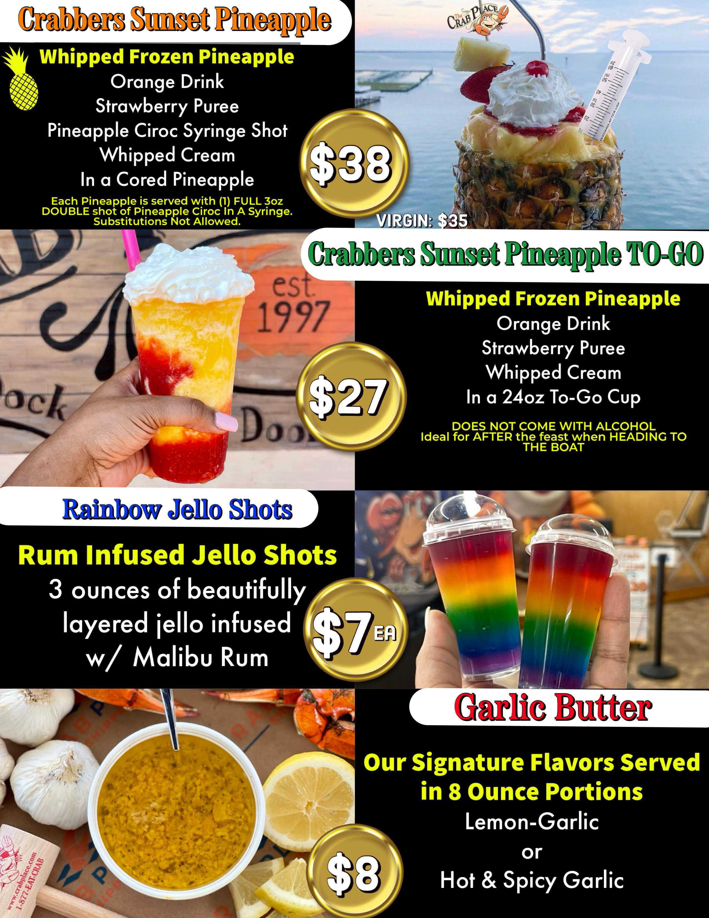

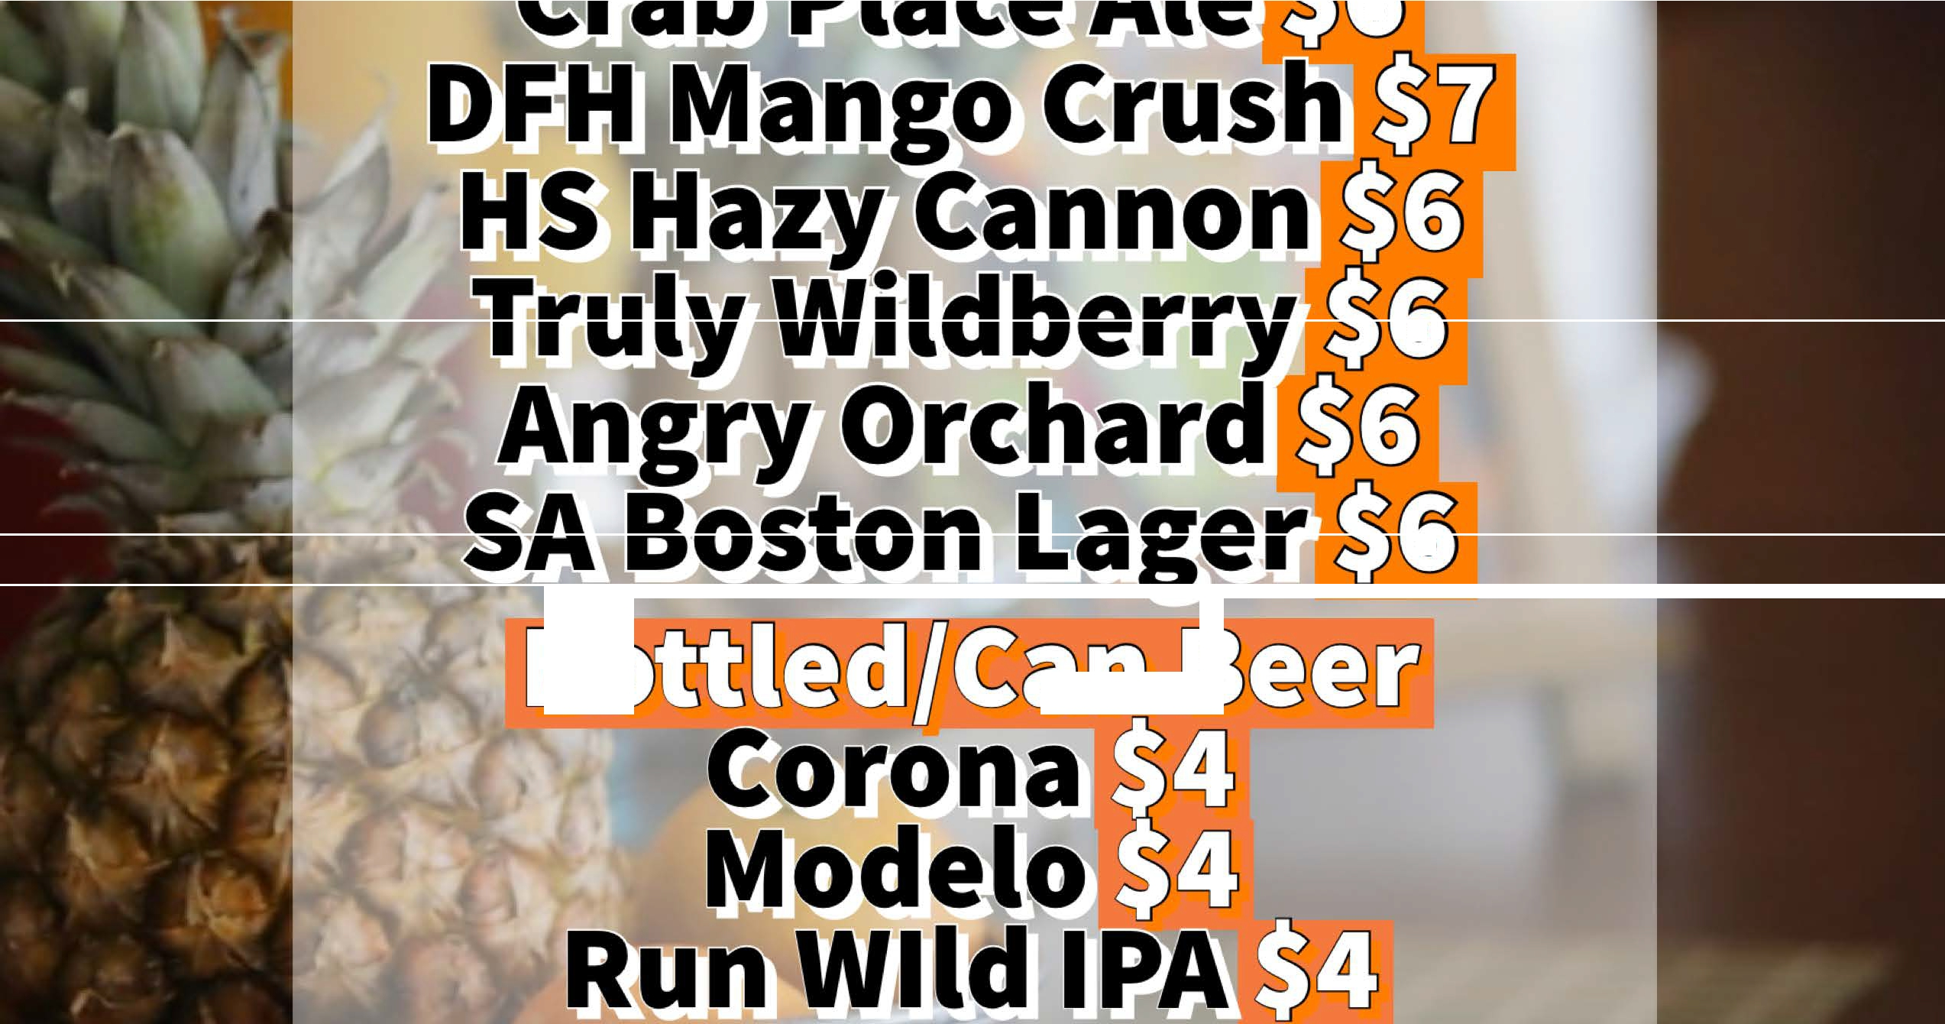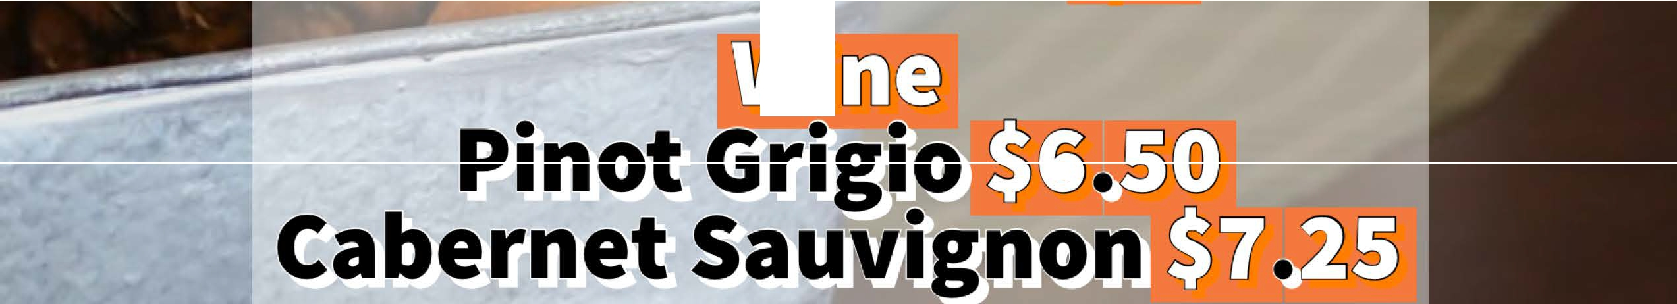

***0*** 0

**0**

***0* D·**

0

0

0

**D** D

D· Q ***0*** D

- 0

0